Ashbrook School Childhood Pledge

The IFTL Childhood Pledge will support me to live an active and flourishing lifestyle so I can make informed and healthy decisions that have a positive effect on my own life and of those around me.
- Learn to play as a team
o Learn how to ride a bike safely
- Take part in a sports day
- Help prepare and cook a healthy meal
The IFTL Childhood Pledge will support me to explore my creativity and imagination whilst allowing me to develop my confidence through the enjoyment of the arts.
- Learn to play a musical instrument
Arts
o Recite a poem
- Perform to an audience
- Visit a theatre
The IFTL Childhood Pledge will support me to have an understanding and appreciation of where I belong within my community, my past, the values and beliefs of others and how all of these impacts on my future.
o Visit a place of worship
- Learn about the history of Ashbrook
- Try foods from other cultures
- Visit a famous landmark
The IFTL Childhood Pledge will support me to work alongside my peers within my own school as well as schools throughout the Trust. We will celebrate each other’s achievements and share our learning journey together.
o Participate in an event with another school
IFTL Community
- Participate in an IFTL competition

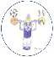
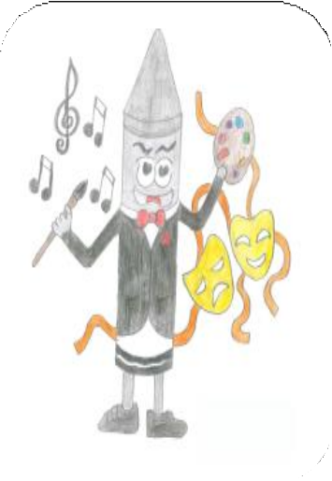
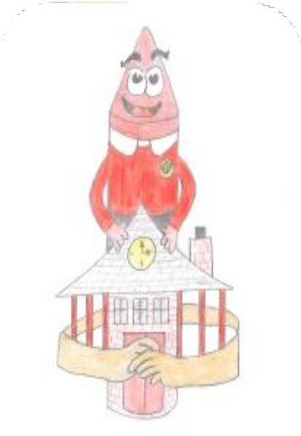
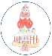
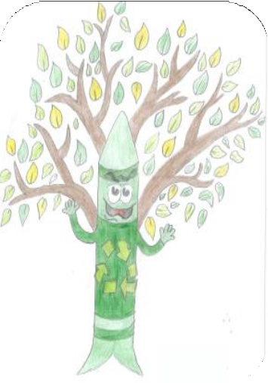
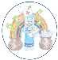
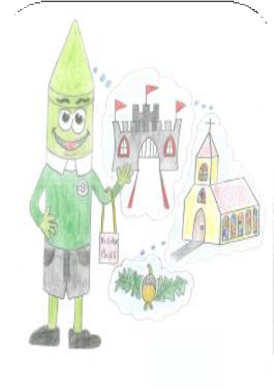
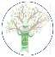
The IFTL Childhood Pledge will support me to engage with others, to develop my understanding of my community and allow me to be a responsible and active citizen.
Citizenship
Active
Culture/Heritage
o Donate to a food bank
o Take part in a National charity Event
o Help people in the community
o Take part in a vote
The IFTL Childhood Pledge will support me to know how to look after the world I live in. I will understand the impact I can have on the world around me and I will strive to care for and protect our planet.
o Complete a litter pick
Environment
o Grow something from a seed
o Go cloud watching
o Complete a year group recycling project
The IFTL Childhood Pledge will support me to learn about money, how to save and spend money sensibly. It helps me to develop my life skills which help me to contribute to my family, learning how to look after myself.
o Learn some basic first aid
Life Skills
o Learn how to cross a road safely
o Grow your own vegetables
o Bake a cake
The IFTL Childhood Pledge will support me to experience a range of adventures which will broaden my knowledge and understanding of the people and places around me. I will welcome visitors into my learning environment.
- Meet a visitor in my school
Visits / Visitors
o Meet an author
- Meet a local hero
o Go on a school trip

